

Copyright ©2026
National Centre for Energy and Environment, Energy Commission of Nigeria, University of Benin:
ISSN 2504-9593
DOI: 10.5281/zenodo.20817740
https://ijree.com/index.php/publications/article/view/69

Int. J. Renew. Energ & Environ Vol.4 (2), pp 189-207(2026)
URBAN EXPANSION AND CHANGES IN NORMALIZED DIFFERENCE VEGETATION INDEX OF BENIN CITY

ANYOKWU, C.O
Department of Geography and Disaster Risk Management, University of Benin, Benin City.
Email: courageonyex@yahoo.com
ABSTRACT
The study examined the trends in urban expansion and changes in vegetation of Benin City between 1991 to 2006 and 2021. The study employed remote sensing and geographic information systems for the spatial analysis. The result of the analyzed data showed a spatio-temporal urban expansion in the built-up area. The built-up area of Benin City increased spatially by 116.67km² between 1991 and 2006 and by 203.67km² between 2006 and 2021. For the 30years period (1991-2021), Benin City witnessed areal expansion of 633.54km². This indicates a remarkable vegetation loss of about 29km² in lieu of urban expansion. The trend of depletion in vegetation was followed up by massive urbanization that led to expansion of the built- up area of 34.4587km² within the periods. Also, findings revealed that there was a corollary between urban expansion and decrease in vegetation. The computed NDVI showed a significant reduction in vegetation of the study area. The NDVI of 1991 was 0.63 (approx.63%), by 2006 it decreased to 0.53 (approx.53%) and by 2021 it has reduced to 0.47 (approx.47%). This was substantiated with the use of one-way Analysis of Variance (ANOVA) in validating the result. The test statistics showed a significant difference in the mean of NDVI for the three consecutive periods (P<0.005). The mean NDVI for the three periods showed, 0.64 in 1992, 0.53 in 2006 and 0.47 in 2022. This implies that, as the city expands, it encroached into vegetated areas progressively. Hence, urban expansion lends credence to decrease in urban vegetation which results in several ecological challenges. In view of this, the study recommends adaptation measures such as afforestation, legislation on deforestation, green revolution, creation of shelter belts, parks and reserves and effective planning that is geared toward creating a conducive environment.
KEYWORDS: Urban expansion, spatial analysis, remote sensing, geographic information system, shelter belt

- INTRODUCTION

Natural landscapes are on daily basis modified, leading to the persistent destruction of natural vegetation. Urbanisation is the process by which settlements develop from rural to urban status (Spence, Annex and Buckley, 2009). It is a substantial increase in population, built up areas, socio-economic activities and improved infrastructure (Odjugo et al, 2015). When this process persists and development is sustained over a long period of time, it is termed urban expansion. Urban expansion is known to replace natural vegetation with artificial concrete surfaces (Ifeanyi, Hart and Wali, 2021). Consequently, the gradual and continuous loss of vegetation has been linked to several ecological problems like drought, extinction of plants and animal species and urban warming experienced in most cities of the world (Ebinemi, Tari and Ibama, 2021). This is because, the forest serves a home for biodiversity and helps in maintaining balance in the ecosystem. Therefore, it becomes necessary for more scientific knowledge and approaches to be established, so as to protect biodiversity and the natural ecosystem for environmental sustainability.
Benin City was selected for this study owing to its vast urban canopy, its high rate of development, areal expansion and for the fact that it faced with several ecological problems (Balogun and Anyokwu, 2023). More so, the city falls under the rainforest belt which is characterised by giant tree and jungles and numerous species of animals. Some scientific studies that have been carried out in this regard on Benin City include those of Ikuoria (1987), Odjugo, Enaruvbe and Isibor (2015), Olayiwola and Igbavboa (2014) and Anyokwu and Balogun (2024) to mention but a few. However, the dynamic nature of urban vegetation, particularly as it relates to areal expansion has not been fully assessed from all scientific perspectives. For this reason, there is the need for more scientific studies that will complement the aforementioned to address the issues identified.

2.0: MATERIALS AND METHODS
2.1: Study Area
Benin City is the administrative headquarters of Edo State, Nigeria. It is located on the southern part of the country. It lies between latitudes 6º 12’N and 6º 28’N of the Equator and between Longitudes 5º 34’E and 5º 44’E of the Greenwich Meridian. It occupies an area of 1,204km², cutting across five local government areas, including Egor, Ikpoba-okha, Oredo, parts of Uhunmwonde and Ovia North-East (Benin City Master Plan, 2023). The city has witnessed rapid areal expansion in recent times, stretching over 180,223.20 hectares between 2008 and 2020 (Efe and Eyefia, 2014). The expansion of the city is closely linked to population increase and its socio-economic prospects. As at 2023, the population of the city was estimated to be 2,950,000, a density of 2,450/Km² and growth rate of 3.99percent per annum (Anyokwu and Balogun, 2024). Benin City is situated within the tropical equatorial rainy climate which favours luxuriant plant growth and dense vegetation. Its evergreen forest reflects a dense tropical high forest (Balogun and Anyokwu, 2023). The Common tree species found around the area are the Milicia excelsa, Chlorophora excels and Swietenia Macrophylla (Iroko, Obeche and Mahogany). However, in recent times there has been drastic encroachment of the forested parts of the city region by unchecked urban expansion, particularly through human activities such as lumbering, farming, mining and road construction among others (Olayiwola and Igbavboa, 2014).
Benin City is located in a strategic position that leads to different parts of the country and this has created great commercial prospect. It has attracted financial institutions, as well as industries to the city (Odjugo, Enaruvbe and Isibor, 2015). Most urban dwellers are engaged in formal occupations, with others employed in the informal sector. Small scale farming is also very common around the metropolitan areas, particularly on the fringe of the region (Anyokwu and Balogun, 2024).

Figure 1: Map of the Study Area
Source: Ministry of Lands and Surveys (2021).

2.2. Methodology
The study examines the impacts of urban expansion on the vegetation of Beni City. A number of procedures were employed in carrying out the investigation. These are discussed under the following headings:

2.3. Data Collection
Data were obtained through remote sensing, processed and analyzed using geospatial techniques. Land use/Land cover (LULC) spatial dimension values and Normalized Difference Vegetation Index (NDVI) values were extracted using geospatial techniques. The data employed are mainly Landsat images and administrative map of the study area. The satellite images were downloaded from the website of the US Geological Survey at www.glcffapp.glcf.umd.edu and NASA website of surface meteorology and solar energy choice at http://www.energycodes.gov. The images were extracted from one scene (path/ row 189/ 056) of Landsat 5TM 1991; Landsat 7 TM 2006 and Landsat 8 ETM+ 2021. The images were all acquired on 24th December. The 30years period is to allow for noticeable changes in LULC patterns and the consequent change in size of urban sphere and to effectively evaluate changes in the vegetation patterns within the period. Table 1, clearly itemized the characteristics of the image used for the work:

Table 1: Characteristics of Landsat Sensor
Satellite sensor | Acquisition date | Spatial resolution | Format | Band required
Landsat5 TM | December, 1991 | 30m | Tiff | 3, 4, and 6
Landsat7 ETM | December, 2006 | 30m | Tiff | 4,5,10 and 11
Landsat8 ETM + | December, 2021 | 30m | Tiff | 5,7, 10 and 11
Source: Landsat metadata file

2.4. Image Classification
The ENVI software was employed in the classification process. This was done using the supervised classification technique which requires a reconnaissance knowledge of the researcher to train the sample set. Thereafter, the algorithm classifier was used to run all the pixels of the image based on the already defined training set into class. Thus, four land use land cover types were identified. These are the built-up, water bodies, cultivation and vegetation. In order to avoid estimating vegetation index of the image outside the study area, clipping was carried out to extract the defined area of the satellite image, as recommended by Hijmans (2018). Hence, the spatial extent of Benin City was extracted from the image using the shape file from the output of a supervised classification method.
2.5. Image Calibration
The Landsat image used has Digital Number (DNs) values which are not calibrated, having atmospheric effects that cannot be used for quantitative analysis. For this reason, image calibration was first carried out. This is basically to correct atmospheric effects and quantized the image into some measure of physical unit (Meng and Chen, 2016). The process involves converting the digital number (DNs) of the image manually using the ArcGIS Raster Calculator. Landsat 8 constants and rescaling factor values used for NDVI are shown in Table 2. These computational values are available in the metadata file.

Table 2: Characteristics of the selected image bands
Band No.  Landsat5 TM/ Landsat7ETM | Wavelength range | Spectral Response | Spatial Resolution
1 | 0.45 - 0.520 | Blue – Green | 30
2 | 0.52 – 0.600 | Green | 30
3 | 0.63 – 0.690 | Red | 30
4 | 0.760 – 0.900 | Near – IR | 30
5 | 1.550 – 1.750 | Mid – IR | 30
6 | 10.40 – 12.50 | Thermal | 120
7 | 2.080 – 2.350 | Mid – IR | 30
Landsat8 ETM+
`4 | 0.636 – 0.673 | Red | 30
5 | 0.851 – 0.879 | Near-infrared | 30
10 | 10.60 – 11.19 | Thermal Infrared ( TIRS 1) | 30
11 | 10.50 – 12.51 | Thermal Infrared (TIRS 2 ) | 30
Source: Landsat metadata file: The computation was based on the following procedures:

2.6. Estimation of Normalized Difference Vegetation Index (NDVI)
The Normalized Difference Vegetation Index (NDVI) shows the proportion of the vegetation in a given area. Hence, NDVI is sensitive to the presence of vegetation on the earth’s surface and it ranges between -1 to +1 (Ebinemi, Tari and Obama, 2021). Its computation is done using two bands; red band 4 and the infra-red band 5 of the Landsat image (Bolstad, 2002). It is expressed as:
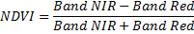

More so, proportion of vegetation (PV) is computed from NDVI using the following equation:
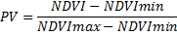
Where,
NDVI = calculated NDVI band output
NDVI_{min} = minimum value of the output NDVI
NDVI_{max} = value of the maximum value of the calculated NDVI output
PV = Proportion of vegetation
The value of 0.986 corresponds to a correction value of the equation.

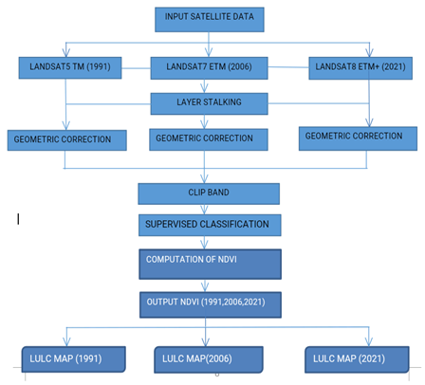
Figure 2: Schematic representation of data analysis
Source: Author, 2026

2.7. Statistical Analysis
To validate the result of the analyzed data, Normalized Difference Vegetation Index (NDVI) values for the three time periods (1991, 2006 and 2021) were extracted from the calibrated Landsat image using ArcGIS application. One-way Analysis of Variance (ANOVA) which is an extension of t-test was used. This becomes necessary when the independent variable also known as factor, consist of more than two groups or conditions within the factor. Thus, the dependent variable is of a ratio measurement scale.
The independent variable is composed of three groups which defined the periods of investigation (1991, 2006 and 2021) with their respective extracted NDVI values. The rationale for using the respective NDVI values is to ascertain if expansion of the built up area corresponds with changes in vegetation patterns. The dependent variable is the vegetation patterns. Since this analysis is based on a single criterion (NDVI), the totals, means and sum of squares were computed for each sampled period. Therefore, the independent variable (x) becomes the periods of expansion in built up area, which is as follows:
x1= built up area in 1991
x2= built up area in 2006
x3= built up area in 2021
Thus, the total, mean and sum of squares of vegetation patterns generated from the period of expansion in the built up area are given as:
…………
1, 2,
………
In One-way ANOVA, differences between means are determined (vegetation patterns generated from the various years) by calculating their variability. The three types of variability are estimated:
- The variation within each group
- The variation between groups
- The total variation of the groups, regardless of the class group to which they belong.
These parameters are determined as follows:
First, the ‘grand mean’ of the vegetation patterns generated from the periods of expansion of the built up area () is computed.
The grand mean is given by:
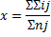
Where: ΣΣx_{ij} is the overall total values of independent variable (the three levels of expansion of the built up area) and Σ_{nj} is the overall total case, N.
Secondly, compute the sums of the sum of squares for each variable. The sums of the sum of squares of vegetation patterns generated from the various years of expansion in built up area. This is given as: ΣΣi²j²
Where: ΣΣi²j² is the sum of the total of the sum of squares of vegetation pattern generated from the three periods of expansion of the built up of the area.
Thus, the total sum of squares of vegetation generated from the three periods of expansion of the built up area is given as:
Where ΣΣi²j² is the sums of the sum of squares of vegetation patterns generated from the periods of expansion of the built up of the area, N is the overall total case and is the grand mean of vegetation patterns generated from the periods of expansion of the built up area.
Then the between-group sum of squares, BSS is given as:
Where Σ_{nj} is the number of observations of each group of expansion in built up,
is the square of the mean of each group of periods of expansion of the built up area, N is overall total case of expansion of the built up area periods and
is the square of the grand mean.
The within-group sum of squares (WSS) is expressed as:
Consequently, the mean square average that is known as variance estimates is computed. The between-group variance estimate is given by: S_{B}²
On the other hand, the within-group variance estimate is given by: S_{W}²
Where N is the overall total case of periods of expansion of the built up area and K is the number of groups of expansion of the built up area periods, which is in this case 3.
The ratio between the variance estimates is known as the Snedecor’s variance ratio test or Snedecor’s F,
Where:
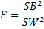 ²
The Snedecor’s F tests the equality of the mean of the vegetation patterns. The confidence level of 0.05 was adopted
3.0: DISCUSSION OF RESULT
3.1. Expansion of the Built-up Area in Benin City between 1991, 2006 and 2021
The built-up area of Benin City as at 1991 was computed to be 116.6661Km². By this time, the built-up of the city comprised of six communities; Ugbowo, Uwelu, Uselu, Ebvogida, Teboga and Aduwawa. At that time, communities like Oregbeni, Avbiama, Ugbor, Eyean, Ute, Okha, Oluku, Iyowa, Idogbo and Ekae were predominantly rural. By 2006, the built-up area of the city has increased spatially. It was computed to be 203.6700Km² as against 116.6661km in 1991. This time, most of the rural areas as at 1991 have become fully urbanized, communities like Iguosa, Idumwonwina, Ekosodin, Eyean, Iyowa and Avbiama, which then increased the urban sphere of the city to twelve communities. Therefore, analysis showed a rapid urban expansion in the size of the city within the 15years period, as the built-up area of the city. By estimation, it showed an expansion of 87km², with an expansion rate of 5.8km² per annum. It could be inferred that the built-up area encroached into other land use types particularly the vegetated area which lost about 175.8 Km², which is at a rate of 11.7Km²per annum.

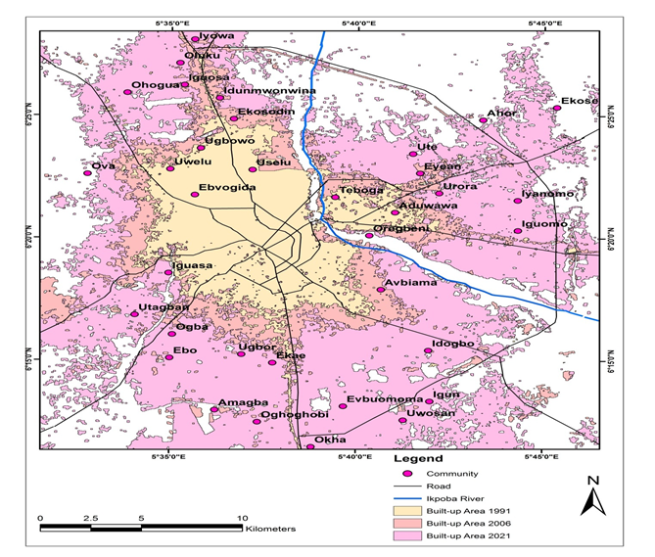
Figure 3. An overlay of the Built-up area of Benin City for 1991, 2006 and 2021
Source: The Author, 2026. Accuracy=92.3151%. Kappa coefficient=0.8845

By 2021 the built-up area of the city was computed to be 633.5460Km² as against 203.6700Km² in 2006. This time, virtually all the communities in the city region have become fully urbanized, except for a few developing communities like Ekose, Ahor, and Ova. The rural communities as at 2006 have become fully built-up, such as Iyanomo, Iguomo, Ohogua, Utagba, Uwosan, Ebo, Ogba, Amagba, Ugbor and Oghoghobi. Thus, the built-up area of the city at present comprised of thirty-two communities. The analyzed data showed the magnitude and rate of change of the built-up area between 2006 and 2021. The information depicted on the tables 4.0 and 5.0 shows that the size of the built-up area of Benin City in 2021 expanded from 203.6700Km² in 2006 to be 633.5460Km² by 2021. Thus, the built-up area increased by 429.8760 Km², which is roughly at a growth rate of 28.6584 Km² per annum. It could also be inferred that the built-up area encroached into other land use types notably the vegetated area with roughly -259.3Km² which is at a rate of 17.3Km².
Therefore, for the period of 30 years under investigation (from 1991 to 2021), a very notable change in the built-up area of Benin City was also observed. The change in magnitude for the built-up area grew from 116.6661Km² to 633.5460Km² which is approximately 516.9km² increase in size (see table 3). The rate of urban expansion within the period was computed to be 34.5km² per annum. The observed information depicted an increase in the size of the built-up area between the period of 30years. In lieu of urban expansion, vegetation depleted by 435.1034km² which is approximately at a rate of 29km² per annum. Also, there was a noticeable decrease of about in the 2.0413 Km² cultivated which is at a rate of 2.0km² per annum. However, the change in the size of water body tends to be negligible within the period (roughly 0.1km²). See Figure 3.
3.2. Normalized Difference Vegetation Index of Benin City in 1991, 2006 and 2021
The Normalized Difference Vegetation Index (NDVI) is used to determine the proportion of vegetation (PV) which is also an important factor in determining the level of vegetation cover in an area (Krakauer, Lakhankar and Anadon, 2017). It is also important to know that NDVI has an index value that ranges between -1 to 1. Thus, NDVI index value ranges indicates that values between -1 to 0 represents water body, from 0.0 to 0.1 represents bare surfaces, barren rocks, sand or snow, from 0.2 to 0.5 represents shrubs, grasses and crops, while from 0.6 to 1.0 represents dense vegetation or tropical rainforest (Bolstad,2002). From the investigation carried out, the computed NDVI values was between 0.23281 and 0.63386. Therefore, results from the visualized NDVI for the year 1991 showed a low NDVI values within the built-up area of between 0.2 (2%) to 0.43 (43%) index values, reflecting the presence of sparse shrubs and grasses within the built–up areas like Uwelu, Ugbowo, Evbogida, Teboga, Ekosodin, Aduwawa and the Central Business District. These areas had low vegetation content due to their urban status as at 1991. On the other hand, communities around the suburb like Oregbeni, Eyean, Iguosa, Ute, Urora, and Avbiama, had moderate vegetation content values between 0.43 (43%) and 0.47 (47%), which indicates a gradual change in land use within the suburb. NDVI values ranging from 0.48 (48%) and 0.63 (63%) indicates a dense vegetation which is typical of a rural setting, as in the case of communities like Iyowa, Ugbor, Iyanomo, Ekose, Iguomo, Idogbo, Igun, Uwosa, Ahor, Oghoghobi, Okha, Evbuomoma, Ogba, Ebo, Amagba, Ekae, Utagban, Ova, Ohogua, and Oluku in the year, 1991(see figure 4).The computed normalized difference vegetation index (NDVI) for 2006 showed a gradual decline in values. For the built-up areas of the city, NDVI values were between -0.0086 (less than 1%) to 0.253 (25%), which indicates a very low vegetation content. Thus, these values represent bare surface, rocks and sand (Meng and Cheng, 2016). The communities that defined the urban sphere at this time include Avbiama, Aduwawa, Teboga, Iguosa, Idunmwonmwinna, Ugbowo, Evbogida, Uselu, and Oregbeni, which were suburbs and rural as at 1991. Again, moderate vegetation content was computed in communities that made up the surbub, in areas of Eyean, Urora, Oluku, Iyowa, Ekae, Ugbor, and Utagban. The computed NDVI value range between 0.253 (25%) and 0.323 (32%), which indicates the represence of shrubs, grasses and crops. Moreso,The NDVI values of between 0.32 (32%) and 0.53 (53%) were record in some communities that constitute the city region. This fairly high NDVI values clearly indicates a notable level of change from rural land use to a more developed landscape of secondary vegetation. The communities that constitute this area are Ute, Iguomo, Iyanomo, Ahor, Ova, Ekose, Igun, and Evbuomoma. However, these communities tend to be predominantly rural as at this time (see figure 5).
The computed NDVI value for the year 2021 for the built-up area were observed to be between 0.0 (less than 1%) and 0.23 (23%). It could be inferred that the built-up area as at this period had little or no element of vegetation cover. That is to say, its features comprised of sands, rocks and bare surfaces. These communities include Ugbowo, Uselu, Oregbeni, Evbuogida, Eyean, Ute, Iguomo, Idogbo, Ugbor, Evbuomoma, Ekae, Oghoghobi, Okha, Aduwawa, Ebo, Ogba, Uwelu, Idumwonmwina, Iguosa, Oluku, and Iyowa. Moreso, communities that were previously densely vegetated as at 2006 could be seen to have low vegetation content, which is indicates a transition in land use and land cover change from rural to urban landscape. Also, it was observed that few areas had NDVI index value of 0.23 (23%) to 0.29 (29%), which depicts moderate vegetation content, indicating secondary vegetation around the suburbs comprising of Uwuosan, Igun, Amagba, Utagban, Ohogua, Ekose, and Iyanomo. Again, It could be inferred that as at 2006 these communities were characterized with rural land use. The computed vegetation index value (NDVI) also revealed a computed index value between 0.29 (29%) and 0.47 (47%), which clearly shows a fairly high vegetation content. The communities that constitute this area are Ahor and Ova (see figure 6). Therefore, it was observed that for the period of 30 years (1991-2021), there has been a remarkable change in land use of Benin City as vegetation seems to have pave way to other urban land use types (see figures 4, 5 and 6).

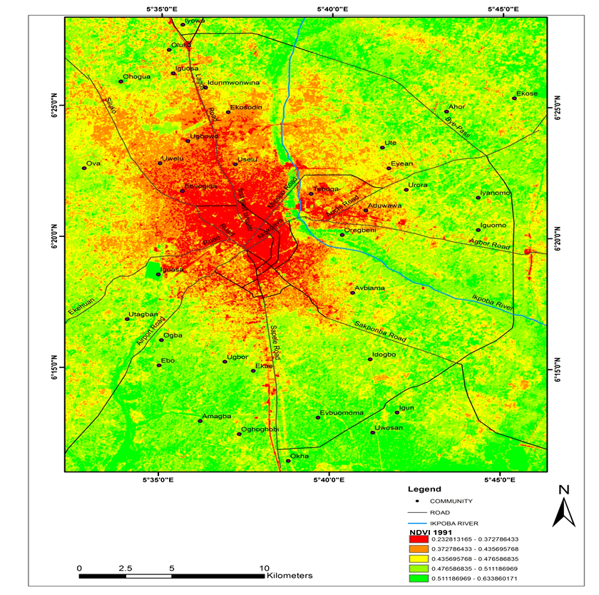
Figure 4. Computed Normalized Vegetation Index of Benin City, 1991
Source: Author, 2026

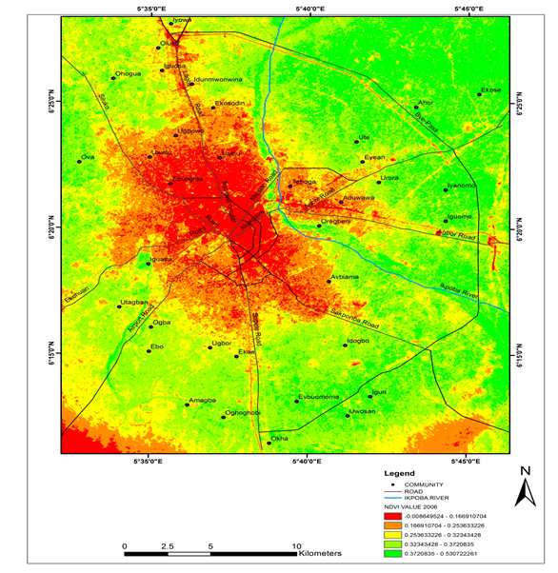
Figure 5. Computed Normalized Vegetation Index values of Benin City, 2006
Source: Author, 2026

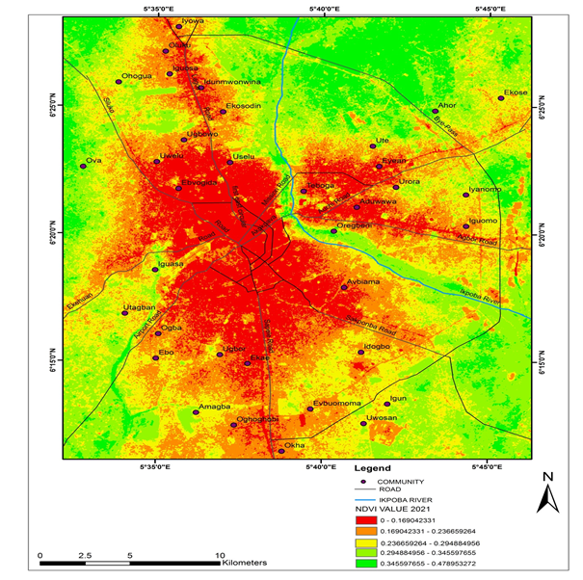
Figure 6. Computed Normalized Difference Vegetation Index values of Benin City,2021
Source: Author, 2026

3.5. Changes in Vegetation Pattern of Benin City in response to urban expansion
Magnitude and rate of change analysis was carried out to ascertain the level of change in the spatial dimension of the various urban land uses and Vegetation of the area within the period under investigation. Within the periods of 1991 and 2006, the magnitude of change in vegetated area was computed to be -175.8323 km² and a rate of change of -11.7222 km² per annum. This means that vegetation decreased by 175.8km² for the period and 11.7 km² annually. From the investigation, the built up expanded by 87km² , farm cultivation increased by about 134km² and water body also increased by 0.2484 km² for the 15 years period. These land uses encroached significantly into the vegetation within the city region. Again, between 2006 and 2021 the magnitude of change for vegetation was computed to be -259.2711km² and rate of change was -17.3km² per annum. This clearly shows that within this period, some portion of the vegetation was encroached upon by mainly the built-up area, which expanded by 429.9km².
Similarly, between 1991 and 2021 the magnitude of change of vegetated area was observed to be -435.1034km² and the rate of change -29km² per annum. It was observed that the vegetation of the area decreased between the aforementioned periods of 30 years. Within the period, the built up area increase spatially by 516.9km². The decrease in the area of vegetation could be attributed to expansion that occurred in the built up areas. The expansion in water bodies within the period tend to be negligible.

Table 3: Urban Land Uses and vegetation of Benin City between 1991, 2006 and 2021
LU/LC  TYPES | Year | Year | Year | MAGNITUDE OF CHANGE  ( 1991-2006) | MAGNITUDE OF CHANGE  (2006-2021) | MAGNITUDE OF CHANGE  (1991-2021)
LU/LC  TYPES | A (1991) | B (2006) | C (2021) | MAGNITUDE OF CHANGE  ( 1991-2006) | MAGNITUDE OF CHANGE  (2006-2021) | MAGNITUDE OF CHANGE  (1991-2021)
Built-up Area | 116.6661Km² | 203.6700Km² | 633.5460Km² | 87.0039 Km² | 429.8760 Km² | 516.8799 Km²
Vegetation | 1105.8518 Km² | 930.0195Km² | 670.7484Km² | -175.8323Km² | -259.2711Km² | -435.1034 Km²
Cultivated Area | 54.5958 Km² | 190.9539Km² | 23.9760Km² | 136.3581Km² | -166.9779Km² | -30.6198 Km²
Water Body | 0.1521 Km² | 0.4005 Km² | 0.2844Km² | 0.2484Km² | -0.1161 Km² | 0.1323 Km²
Source: Author, 2026.
Table 4: Magnitude and Rate of change in vegetation of Benin City between 1991, 2006 and 2021 in respect to changes in Land use patterns
LU/LC TYPE | Magnitude of change  (1991-2006) | Magnitude of change  (2006-2021) | Magnitude of change  (1991-2021) | Rate of change  (1991-2006)/N | Rate of change  (2006-2021)/N | Rate of change  (1991-2021)/N
Built-up Area | 87.0039 Km² | 429.876 Km² | 516.8799Km² | 5.8003 Km² | 28.6584 Km² | 34.4587 Km²
Vegetation | -175.8323 Km² | -259.2711Km² | -435.1034Km² | -11.7222 Km² | -17.2847 Km² | -29.0069 Km²
Cultivated Area | 136.3581 Km² | -166.9779Km² | -30.6198 Km² | 9.0905 Km² | -11.1319 Km² | -2.0413 Km²
Water Body | 0.2484 Km² | -0.1161 Km² | 0.1323 Km² | 0.0166 Km² | -0.0077 Km² | 0.0088 Km²
Source: Author, 2026.
Table 5: Rate of change in NDVI with respect to urban expansion of Benin City between 1991, 2006 and 2021
Land use | Rate of change  ( 1991-2006) | Rate of change  (2006-2021) | Rate of change  (1991-2021) | Magnitude of  Change  (1991-2021)
Built Up Area | 5.8 Km² | 28.7Km² | 34.5Km² | 516.9km²
Vegetation | -11.7km² | - 17.3km² | -29.0km² | 435.1km²
NDVI | -5.3% | -51% | -56.3% | -65.4%
Source: Author, 2026

Therefore, to validate the response of vegetation to expansion of Benin City between 1991, 2006 and 2021, Analysis of Variance (ANOVA) test was conducted. The input data were generated from Landsat 5TM, 7ETM and 8ETM+ (see Table 1). The output result as depicted in Table 7. shows that the mean NDVI for 1991 was 0.91 (S.D=1.4724), the mean NDVI for 2006 was 0.987 (S.D=1.6133) and the mean NDVI for 2021 was 0.994 (S.D=1.5942).

Table 6: ANOVA Descriptive Table on NDVI changes
 | N | Mean | Std. Deviation | Std. Error | 95% Confidence Interval for Mean |  | Minimum | Maximum
 |  |  |  |  | Lower Bound | Upper Bound | Minimum | Maximum
year 1991 | 1156 | .91  .94  .95  2.8 | 1.4724 1.6133 1.5942  2.4029 | .0433 | .417 | .587 | .0  .0  .0  .0 | .98  .987  .994
year 2006 | 4359 | .91  .94  .95  2.8 | 1.4724 1.6133 1.5942  2.4029 | .0244 | .027 | .123 | .0  .0  .0  .0 | .98  .987  .994
year 2021 | 5636 | .91  .94  .95  2.8 | 1.4724 1.6133 1.5942  2.4029 | .0212 | .541 | .625 | .0  .0  .0  .0 | .98  .987  .994
Total | 11151 | .91  .94  .95  2.8 | 1.4724 1.6133 1.5942  2.4029 | .0228 | .709 | .799 | .0  .0  .0  .0 | .98  .987  .994
Source: Author, 2026

A significance difference in mean was observed to be F (11150) =7165.617, P<0.000 (see table 8). Therefore, since the significant level is less than the adopted confidence level of 0.05 it implies that there is a significant difference in the mean NDVI of Benin City for the period under between 1991, 2006 and 2021. This goes to show that as Benin City increased in the built up area within the period and its vegetation index decreased progressively. Again, the mean NDVI computed from satellite images of 1991, 2006 and 2021 were computed to be 0.981 , 0.986 and 0.987 respectively.

Table 7: ANOVA Table on NDVI values
 | Sum of Squares | Df | Mean Square | F | Sig.
Between Groups  Within Groups  Total | 36212.044  28168.674  64380.718 | 2  11148  11150 | 18106.022 2.527 | 7165.617 | .000
Source: Author, 2026

Again, Post-hoc analysis was also carried out to ascertain the difference in mean of NDVI between the designated periods (1991, 2006 and 2021). Table 9 shows the output of the post-hoc (multiple comparisons) analysis of the data. From the result, there was a remarkable difference in the mean of NDVI between 1991 and 2006. Also, a significant difference in NDVI was observed between 2006 and 2021. Similarly, a mean difference in NDVI was also observed between 1991 and 2021. By implication, as the built up area increase spatially over the years, the NDVI decreased progressively. It could be inferred that there is a relationship between change in the size of the urban area and change in vegetation patterns.

Table 8: Post-Hoc analysis on response of vegetation to expansion of Built up Area
(I) Lst_year values | (J) Lst_year values | Mean  Difference (I-J) | Std. Error | Sig. | 95% Confidence Interval
 |  |  |  |  | Lower Bound | Upper Bound
year 1991 | year 2006 year 2021 | -5.5734* | .0526 | .000 | -5.697 | -5.450
year 1991 | year 2006 year 2021 | -6.0812* | .0513 | .000 | -6.202 | -5.961
year 2006 | year 1991 year 2021 | 5.5734* | .0526 | .000 | 5.450 | 5.697
year 2006 | year 1991 year 2021 | -.5078* | .0321 | .000 | -.583 | -.433
year 2021 | year 1991 year 2006 | 6.0812* | .0513 | .000 | 5.961 | 6.202
year 2021 | year 1991 year 2006 | .5078* | .0321 | .000 | .433 | .583
*. The mean difference is significant at the 0.05 level.
Source: Author, 2026

4. Conclusion
The findings of this work showed that urban expansion and its accompanied changes in urban land use patterns results in the changes in vegetation patterns of Benin City over time. Within the 30years period (1991-2021), the city wittnessed a rapid areal expansion of 516.9 Km² in the built-up of the city, which led to 435.1Km² reduction in urban vegetation. The accompanied changes in land use patterns resulting from urban expansion led to a steady decline in vegetation index of the area, from a maximum NDVI of 0.63 (63%) in 1991 to maximum of 0.53 (53%) in 2006 and to maximum of 0.48 (48%) in 2021. This indicates a steady decline in vegetaion content from 63% to 48% which is approximately 15% vegetal loss within the period of 30years. This significant loss of vegetation could be attributed to spatio-temporal changes in urban land use patterns which led to increase in built-up areas. However, this is evident with clusters of tall concrete buildings, tare roads, dense industrial activities, commercial activities and an increase in the flow of traffic in Benin City, as in other large cities of the world (Begue, Vintrou and Claden, 2011). This helps to further consolidate the fact that urban expansion has impacts on the vegetation patterns of urban area as noted in the works of Lambin and Erhlich (1996), Onaiwu and Onaiwu (2019), Ifeanyi, Hart and Wali (2021) and Abotutu (2016). Therefore, urban expansion has a corollary effect on vegetation within the urban sphere of a city, which tends to differ from those observed in the suburb. It is also interesting to know that urban expansion will continuously elicit changes in land use which in turn induce changes in vegetation patterns. This is because intense socio-economic activities will always continue in other to meet the demand of the ever-increasing urban population. Consequently, the destruction of natural vegetation, displacement and extinction of biodiversity will be on an increase. It therefore becomes necessary to adopt relevant mitigation strategies, like afforestation/re-afforestation to complement vegetal loss, provision of alternative sources of energy to reduce the reliance on firewood and the establishment of reserves and parks to ensure the preservation of biodiversity and legislation on deforestation to help curb illegal lumbering activities, overgrazing and bush burning.

REFERENCES
Abotutu, A.A. (2016). The impact of urbanization on the vegetation of Abraka and its environs. African Journal of Environmental Studies, 2, 16-44.
Adebayo, W.O. (2007). Heat Island and Oasis, effect of vegetative canopies: A micrometeorological investigation. International Journal of Urban and Region Affairs, 1(1), 35-40.
Amer, k. Parham, P., & Behnaz, B. (2017). Land use analysis on land surface temperature in urban areas using geographically weighted regression and land sat 8 imagery, case study: Tehran, Iran. The international archives of the photogrammetry, remote sensing and spatial information sciences, volume XLII-4/WA, 2017 Assessed
Anyokwu, C.O. & Balogun, T.F (2024). Spatio-temporal change in land use, land cover and emissivity of Benin City. African Journal of geographical sciences, 5(1) 27-41
Balogun, T.F. & Anyokwu, C.O (2023). Impact of spatio-temporal urban growth on land surface temperature of Benin City, Nigeria. Benin Journal of geography, planning and environment, 3(1), 125-144.
Begue, A. Vintrou, E. Ruelland, D. Claden, M. & Dessey, N (2011). Can a 25years trend in Soudano-Sahelian vegetation dynamics be interpreted in terms of a land use change? A remote sensing approach. Journal of global environmental change, 21(2),413-420. https://doi.org/10.1016/j.gloenvcha.2011.02.002
Bolstad, P. (2002). GIS Fundamentals: A first text on Geographic Information Systems. Eider Press, White Bear Lake, 89-109
Ebinemi, I.E., Tari, E., & Obama, B. (2021). Spatio-temporal dynamics of land use changes in Yenegoa City. MOJ Ecology & Environmental Sciences, 6 (4) 127-134. doi.10.15406/mojes2021.06.00225
Edo State Government (2023). Benin City Master Plan 2023-2053. Ministry of physical planning, urban and regional development, 1(1), 5-38
Efe, S.I. & Eyefia, A.O. (2014). Urban warming in Benin City, Nigeria. Atmospheric and climate sciences, 4, 241-252.
Eruotor, S. (2014). Geography made simple; senior school geography. Tonad publication, fourth edition (144-149).
Hijman (2014). Raster geographic data analysis and modeling. Raster package version, 2.84, https://CRAN.R-project.org/package=raster
Ifeanyi, C.E., Hart, L. & Wali, E. (2021). Spatio-temporal changes of land use/land cover classes in the urban wetland area of Yenegoa Local Government Area of Bayelsa State. Nigerian Journal of Geography, Environment & Earth Science International, 25 (10) 194-207. doi.10.9734/JGEESI/2021/v25.1030325
Ikhile, C.I. (2016). Geomorphology and hydrology of the Benin region, Edo State. International Journal of Geosciences, 07(02), 144-157.
Ikhuoria, A.I. (1987). Rapid urban growth and urban land use patterns in Benin City, Nigeria. Land use policy, 01(4), 62-75.
Krakauer, N. Lakhankar, T. & Anadon, J (2017). Mapping and attributing normalized difference vegetation index trends for Nepal. Journal of Remote Sensing, 9(10). https://doi.org/10.3390/rs9100986.
Lambin, F.F., & Ehrlich, D. (1996). The surface temperature-vegetation index space for land use and land cover change analysis. International Journal of Remote Sensing 17(3), 463-487.
Meng, L., Xin, C. & Chen, X. (2016). Method of land cover classification accuracy assessment considering edges. Journal of Earth Sciences, 9(2)23-39
Nkeki, N.F., & Asikhia, M.O. (2021). Quantifying the urban built environment: A neighborhood-scale analysis. Team Journal of land use, mobility & environment, 14 (2) 189-209. doi.10.6093/1970-9870/8003
Odjugo, P., Enaruvbe, G. & Isibor, H. (2015). Geospatial approach to spatio-temopral pattern of urban growth in Benin City, Nigeria. African Journal of Environmental Science and Technology, 9(3), 166-175.
Okhakhu, P.A. (2016). Assessment of the urban climate of Benin City, Nigeria. Journal of Environment and Earth Science, 6(1), 131-143.
Olayiwola, A. & Igbavboa, O. (2014). Land use dynamics and expansion of the built up area in Benin City, Nigeria. Mediterranean Journal of Social Science, 5.
Onaiwu, D.N. & Onaiwu, F.O. (2019). Impact of sprawl on the peri-urban areas. Geographia online. Malaysia Journal of Society & Space, 15(2) 1-14.
Spence, M., Annez, P.C. & Buckley, R.M. (2009). Urbanization and growth; World Bank, Washington. 2(3)22-29.

